**Experiment 6:** Draw a USE-CASE diagram for Online college management System Manage student’s information and status, manage courses and subjects, Manage Instructors and designation, record all transactions Draw a USE-CASE diagram for Online Airline Management System which is a dedicated and highly configurable system for all airlines, which can be easily accessed by all users. It helps the users to book flights without visiting offline booking counters. This system can be accessible by any user from any location at any time. In such a system, a passenger should be able to view the availability of flights’ details, as per their requirement. They can book the flights online and can also cancel the reservation. The administrator manages the passenger booking system and updates the reservation status using CASE tools.

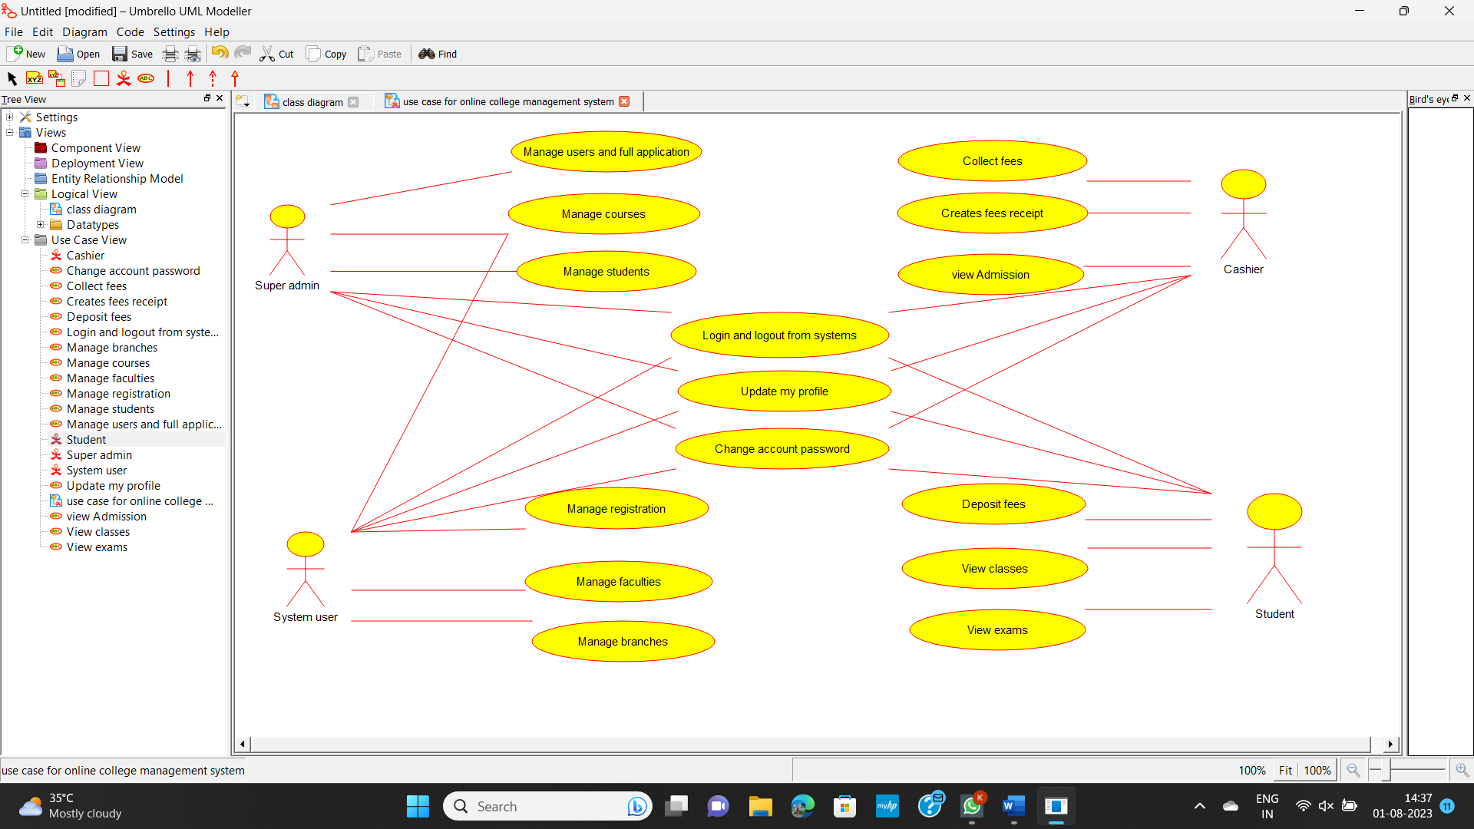

**Experiment 7:** Draw a Use Case diagram for a Restaurant Systems. The activities of the Restaurant system are listed below. Receive the Customer food orders, Produce the customer ordered food, Serve the customer with their ordered food, collect payment from Customers, Store customer payment details, Order Raw Materials for food products, Pay for Raw Materials and Pay for Labour.

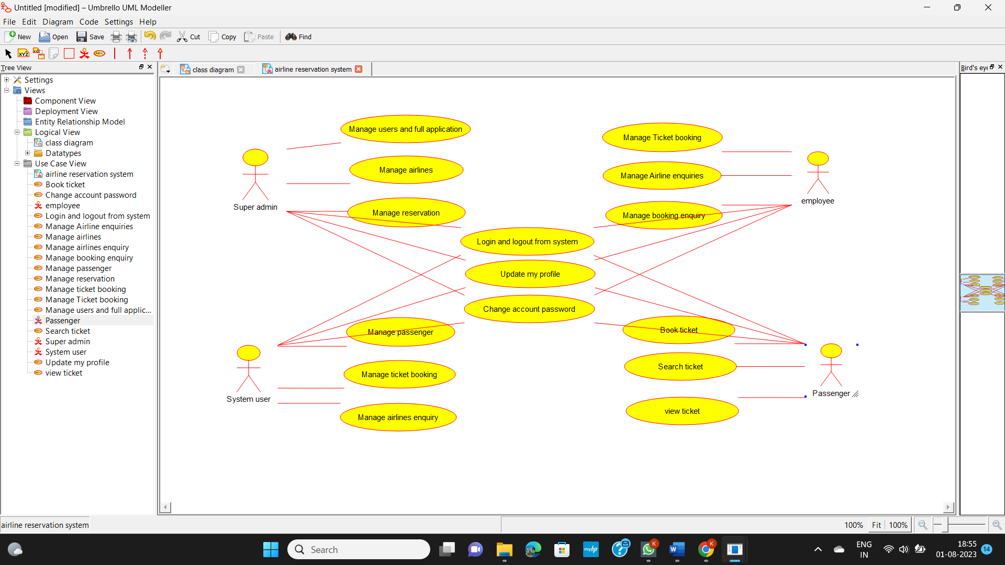

**Experiment 8:** Draw a Use Case diagram for a Restaurant Systems. The activities of the Restaurant system are listed below. Receive the Customer food orders, Produce the customer ordered food, Serve the customer with their ordered food, collect payment from Customers, Store customer payment details, Order Raw Materials for food products, Pay for Raw Materials and Pay for Labour.

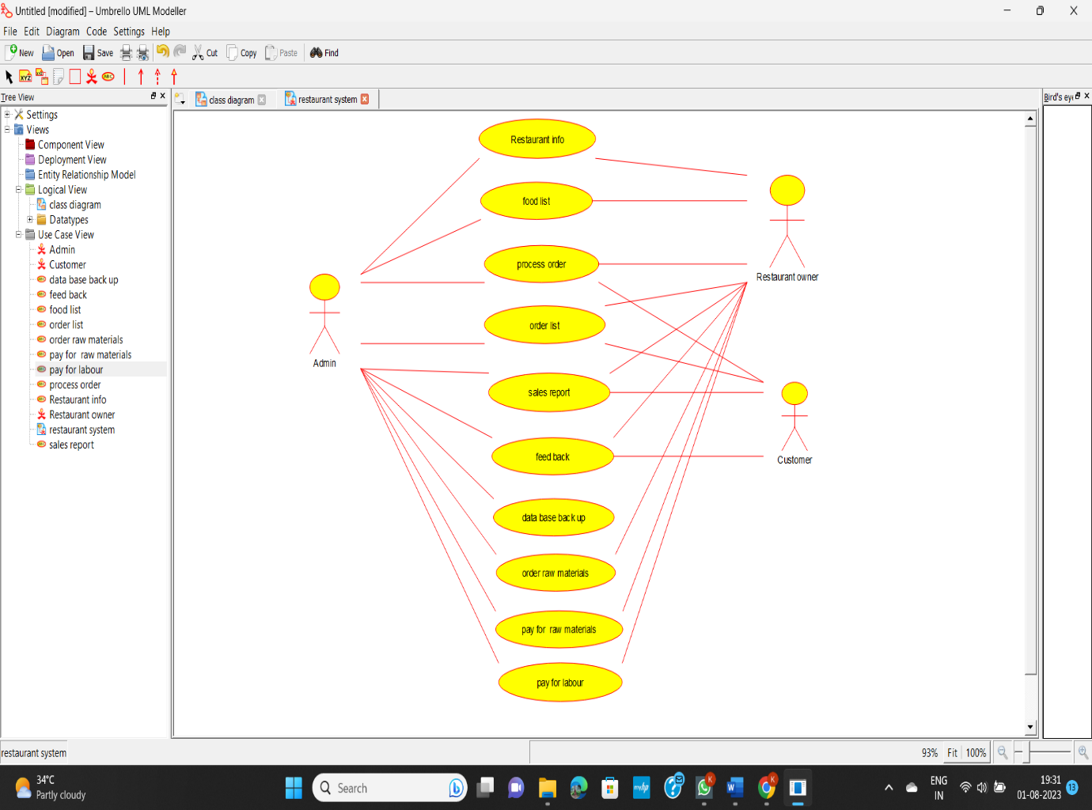

**Experiment 9:** Draw a Use case diagram to model for a quiz system. A user can request a quiz for the system. The system picks a set of questions from its database, and composes them together to make a quiz. It rates the user’s answers and gives hints if the user requests it. In addition to users, we also have helpers who provide questions and hints. And also, administrators who must certify questions to make sure they are not too trivial, and that they are correct

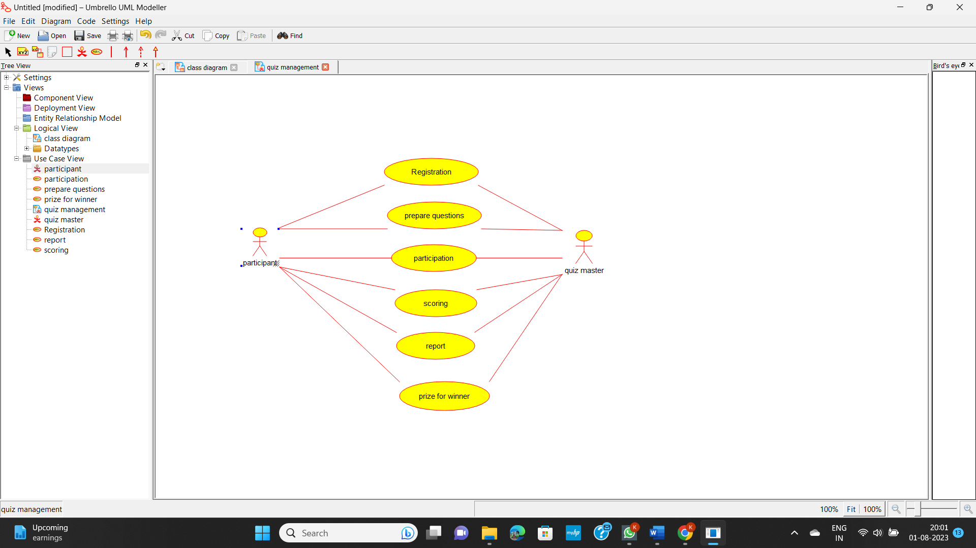

**Experiment 10:** E-wallet is an online prepaid account where one can stock money, to be used when required. As it is a pre-loaded facility, consumers can buy a range of products from airline tickets to grocery without swiping a debit or credit card. You are required to design a similar E Wallet Management System (EMS) using Use case diagram

